EXPERIMENTAL REPORT 4

**DETERMINATION OF GRAVITATIONAL ACCELERATION USING**

**SIMPLE PENDULUM OSCILLATION WITH PC INTERFACE**

**I. EXPERIMENTAL DATA**

**1. Pendulum with vertical oscillation plane**

| **Trial** | $l_{1}=0.350(m)$ $T_{1}\left(s\right)$ | $l_{2}=0.450(m)$ $T_{2}\left(s\right)$ | $l_{3}=0.550(m)$ $T_{3}\left(s\right)$ | $l_{4}=0.650(m)$ $T_{4}\left(s\right)$ |
| --- | --- | --- | --- | --- |
| 1 | 1.207 | 1.428 | 1.517 | 1.645 |
| 2 | 1.217 | 1.434 | 1.538 | 1.657 |
| 3 | 1.209 | 1.428 | 1.534 | 1.645 |
| 4 | 1.217 | 1.415 | 1.530 | 1.658 |
| 5 | 1.222 | 1.421 | 1.530 | 1.653 |
| Average | $\underline{T_{1}}=1.214\left(s\right)$ $ΔT_{1}=\sqrt{\frac{\sum_{i=1}^{5}{}{\left(T_{i}-\underline{T_{1}}\right)}^{2}}{25}}=0.025\left(s\right)$ $⇒T_{1}=1.214±0.025(s)$ | $\underline{T_{2}}=1.425\left(s\right)$ $ΔT_{2}=\sqrt{\frac{\sum_{i=1}^{5}{}{\left(T_{i}-\underline{T_{2}}\right)}^{2}}{25}}=0.029\left(s\right)$ $⇒T_{2}=1.425±0.029(s)$ | $\underline{T_{3}}=1.530\left(s\right)$ $ΔT_{3}=\sqrt{\frac{\sum_{i=1}^{5}{}{\left(T_{i}-\underline{T_{3}}\right)}^{2}}{25}}=0.032\left(s\right)$ $⇒T_{3}=1.530±0.032(s)$ | $\underline{T_{4}}=1.652\left(s\right)$ $ΔT_{4}=\sqrt{\frac{\sum_{i=1}^{5}{}{\left(T_{i}-\underline{T_{3}}\right)}^{2}}{25}}=0.025\left(s\right)$ $⇒T_{3}=1.652±0.025(s)$ |

**2. Pendulum with inclined oscillation plane**

| **Trial** | $θ_{1}=0^{0}$ $T_{1}\left(s\right)$ | $θ_{2}={15}^{0}$ $T_{2}\left(s\right)$ | $θ_{3}={35}^{0}$ $T_{3}\left(s\right)$ | $θ_{4}={45}^{0}$ $T_{4}\left(s\right)$ | $θ_{5}={65}^{0}$ $T_{5}\left(s\right)$ |
| --- | --- | --- | --- | --- | --- |
| 1 | 0.789 | 0.802 | 0.868 | 0.911 | 1.353 |
| 2 | 0.781 | $0.760$ | $0.860$ | 0.931 | 1.322 |
| 3 | 0.798 | 0.752 | 0.843 | 0.944 | 1.295 |
| 4 | 0.773 | 0.781 | $0.830$ | 0.907 | 1.335 |
| 5 | 0.760 | $0.798$ | 0.830 | 0.902 | 1.353 |
| Average | $\underline{T_{1}}=0.780\left(s\right)$ $ΔT_{1}=\sqrt{\frac{\sum_{i=1}^{5}{}{\left(T_{i}-\underline{T_{1}}\right)}^{2}}{25}}=0.013\left(s\right)$ $⇒T_{1}=0.780±0.013(s)$ | $\underline{T_{2}}=0.779\left(s\right)$ $ΔT_{2}=\sqrt{\frac{\sum_{i=1}^{5}{}{\left(T_{i}-\underline{T_{2}}\right)}^{2}}{25}}=0.020\left(s\right)$ $⇒T_{2}=0.779±0.020(s)$ | $\underline{T_{3}}=0.846\left(s\right)$ $ΔT_{3}=\sqrt{\frac{\sum_{i=1}^{5}{}{\left(T_{i}-\underline{T_{3}}\right)}^{2}}{25}}=0.015\left(s\right)$ $⇒T_{3}=0.846±0.015(s)$ | $\underline{T_{4}}=0.919\left(s\right)$ $ΔT_{4}=\sqrt{\frac{\sum_{i=1}^{5}{}{\left(T_{i}-\underline{T_{4}}\right)}^{2}}{25}}=0.016\left(s\right)$ $⇒T_{4}=0.919±0.016(s)$ | $\underline{T_{5}}=1.332\left(s\right)$ $ΔT_{5}=\sqrt{\frac{\sum_{i=1}^{5}{}{\left(T_{i}-\underline{T_{5}}\right)}^{2}}{25}}=0.021\left(s\right)$ $⇒T_{5}=1.332±0.021(s)$ |

**II. DATA PROCESSING**

**1. Determine the gravitational acceleration as a function of pendulum length**

a) $l_{1}=0.350 \left(m\right)$

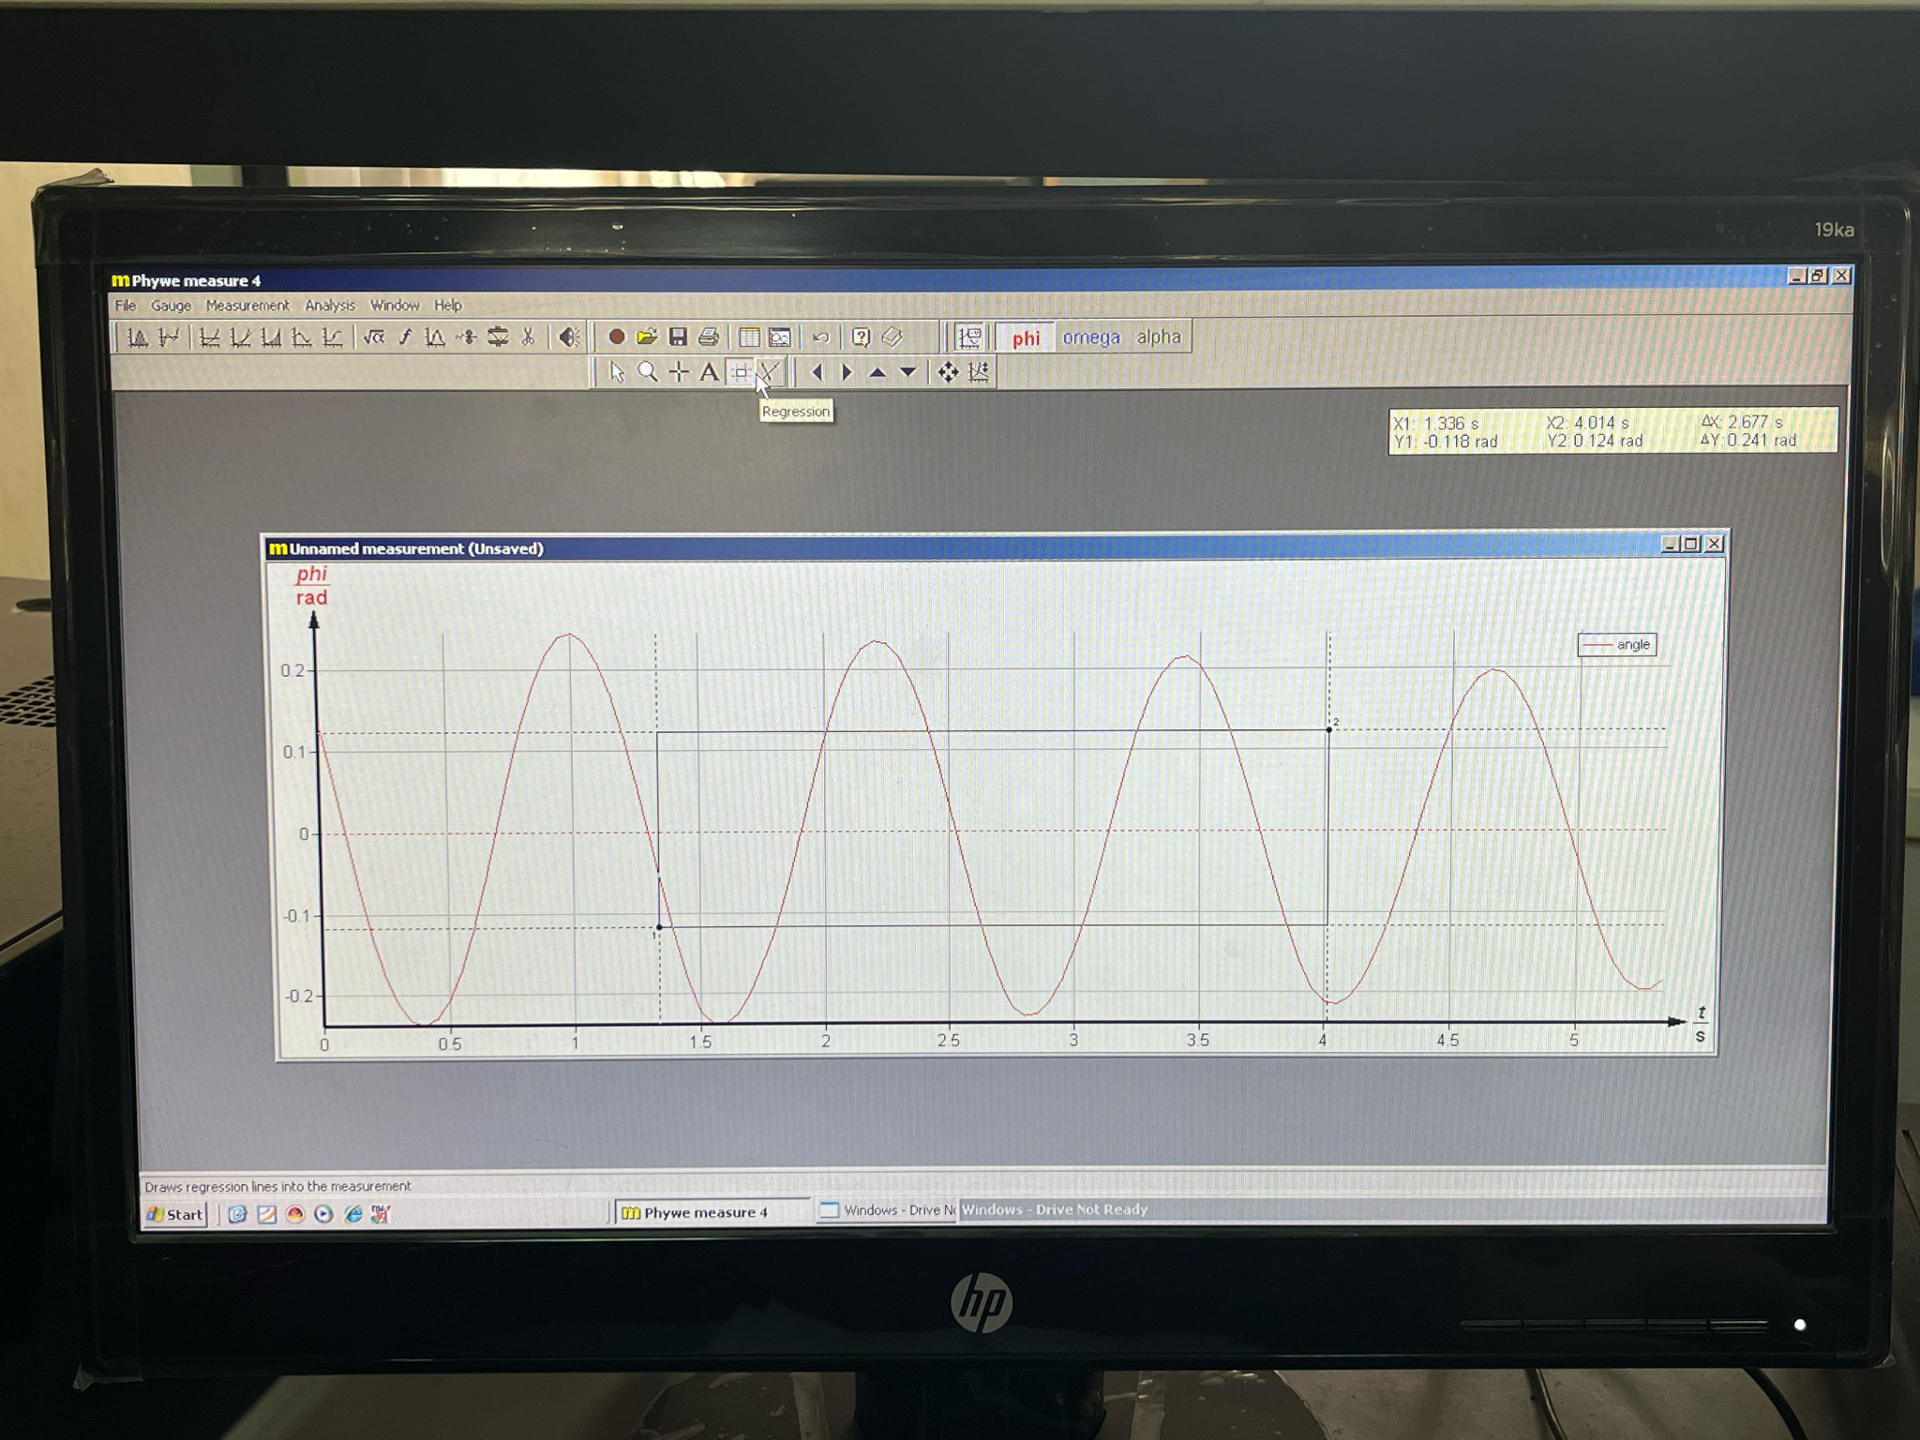

${\underline{g_{1}}=l}_{1}{\left(\frac{2π}{\underline{T_{1}}}\right)}^{2}=0.350×{\left(\frac{2π}{1.214}\right)}^{2}=9.375\left(m/s^{2}\right)$

$Δg_{1}=\underline{g_{1}}×{\left(2\frac{ΔT_{1}}{\underline{T_{1}}}\right)}^{}= 9.375 × 2 × \frac{0.025}{1.214}=0.386$ $\left(m/s^{2}\right)$

$⇒g_{1}=9.375±0.386\left(m/s^{2}\right)$

b) $l_{2}=0.450 \left(m\right)$

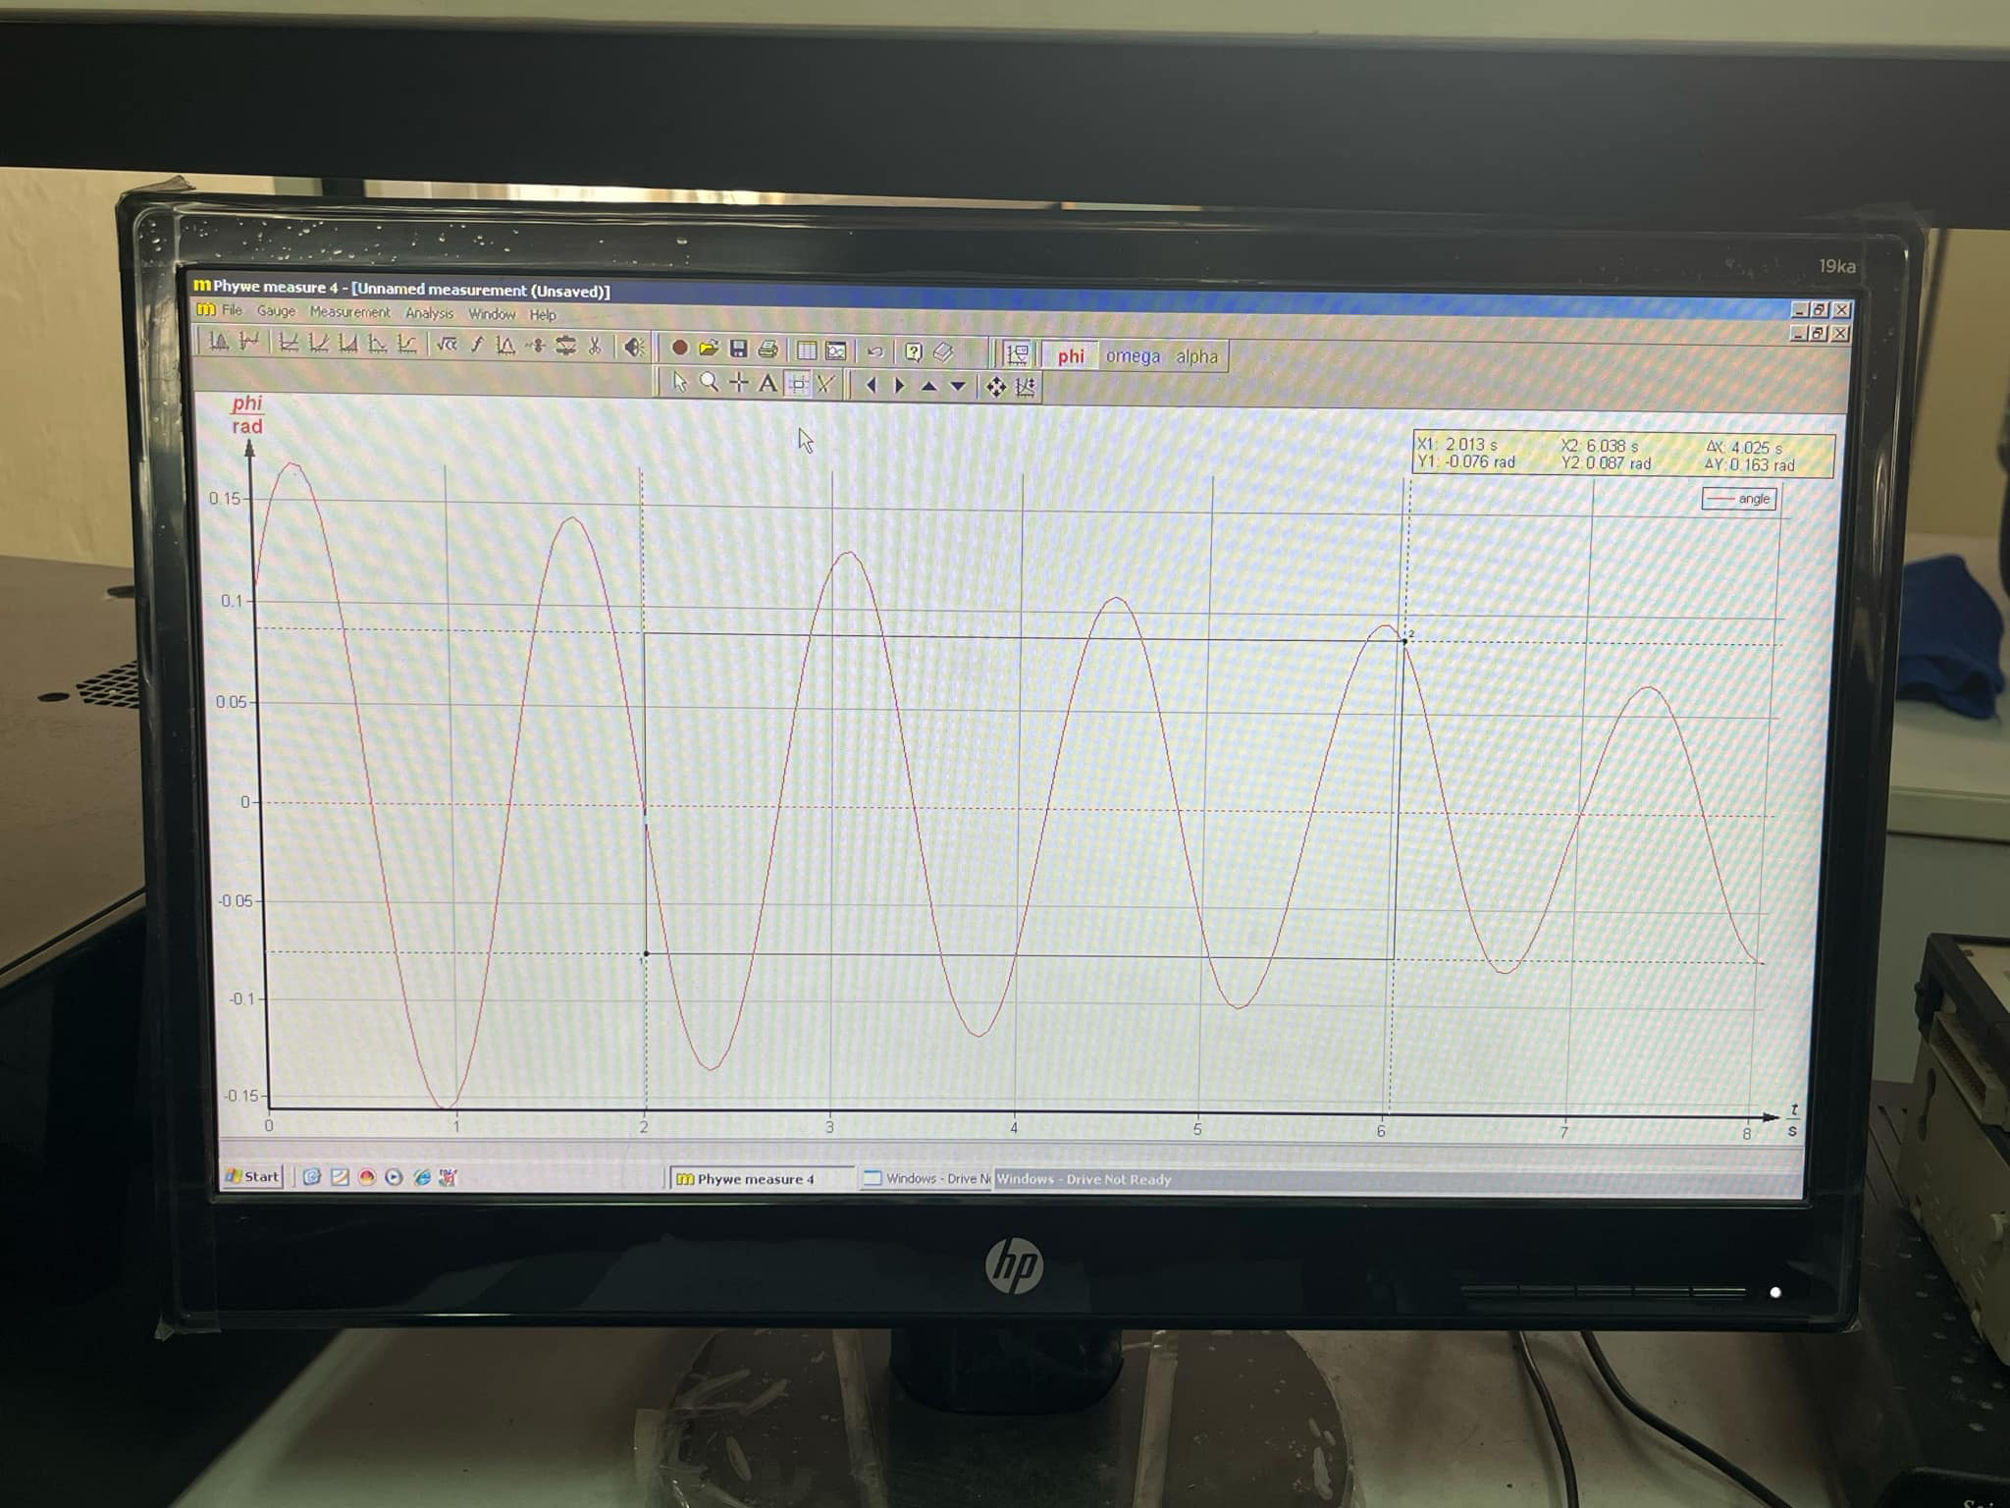

${\underline{g_{2}}=l}_{2}{\left(\frac{2π}{\underline{T_{2}}}\right)}^{2}=0.450×{\left(\frac{2π}{1.425}\right)}^{2}=8.749\left(m/s^{2}\right)$

$Δg_{2}=\underline{g_{2}}×{\left(2\frac{ΔT_{2}}{\underline{T_{2}}}\right)}^{}=8.749$ $× 2 × \frac{0.029}{1.425}$ = 0.356 $\left(m/s^{2}\right)$

$⇒g_{2}=8.749±0.356 \left(m/s^{2}\right)$

c) $l_{3}=0.550 \left(m\right)$

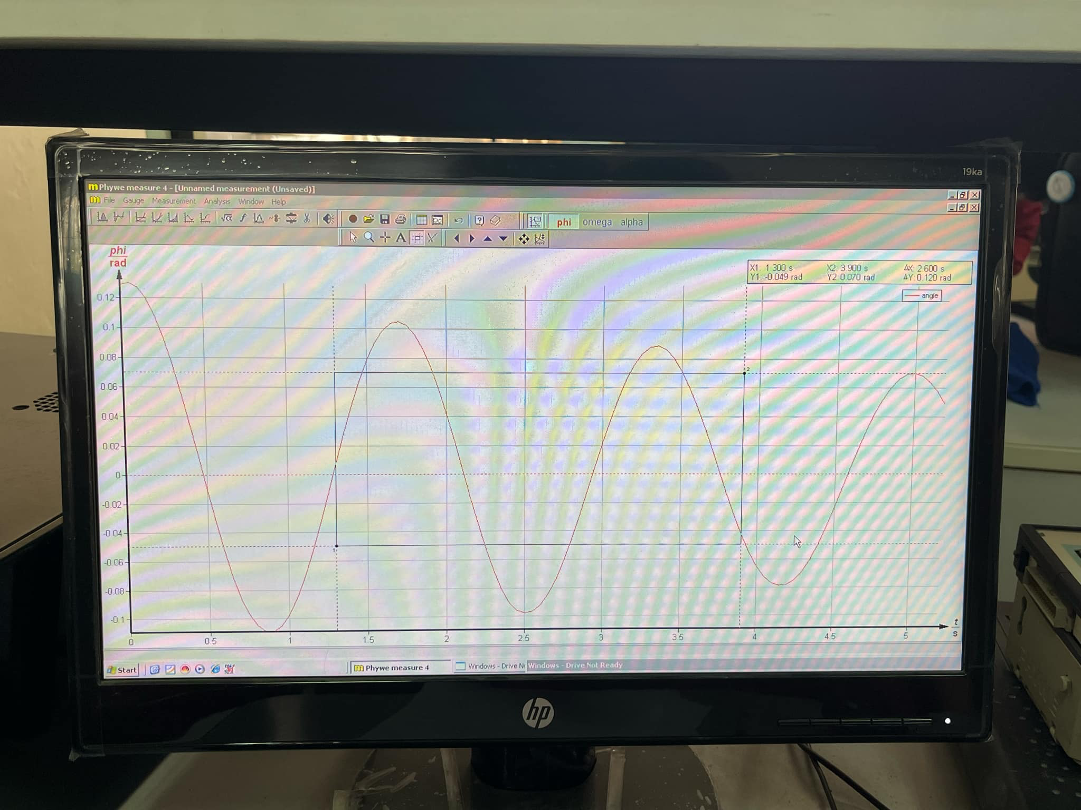

${\underline{g_{3}}=l}_{3}{\left(\frac{2π}{\underline{T_{3}}}\right)}^{2}=0.550×{\left(\frac{2π}{1.530}\right)}^{2}=9.276 \left(m/s^{2}\right)$

$Δg_{3}=\underline{g_{3}}× \left(2\frac{ΔT_{3}}{\underline{T_{3}}}\right)= 9.276 × 2 × \frac{0.032}{1.530}$ = 0.388 $\left(m/s^{2}\right)$

$⇒g_{3}=9.276±0.388 \left(m/s^{2}\right)$

d) $l_{4}=0.650\left(m\right)$

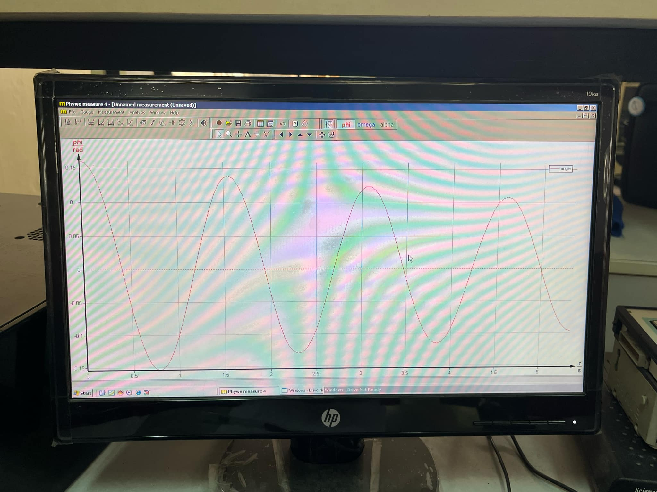

${\underline{g_{4}}=l}_{4}{\left(\frac{2π}{\underline{T_{4}}}\right)}^{2}=0.650×{\left(\frac{2π}{1.652}\right)}^{2}=9.403 \left(m/s^{2}\right)$

$Δg_{4}=\underline{g_{4}}× \left(2\frac{ΔT_{4}}{\underline{T_{4}}}\right)= 9.403 × 2 × \frac{0.025}{1.652}$ = 0.285 $\left(m/s^{2}\right)$

$⇒g_{3}=9.403±0.285 \left(m/s^{2}\right)$

**2. Determine the gravitational acceleration as a function of the inclination of the pendulum force**

a) $θ_{1}=0^{0}$

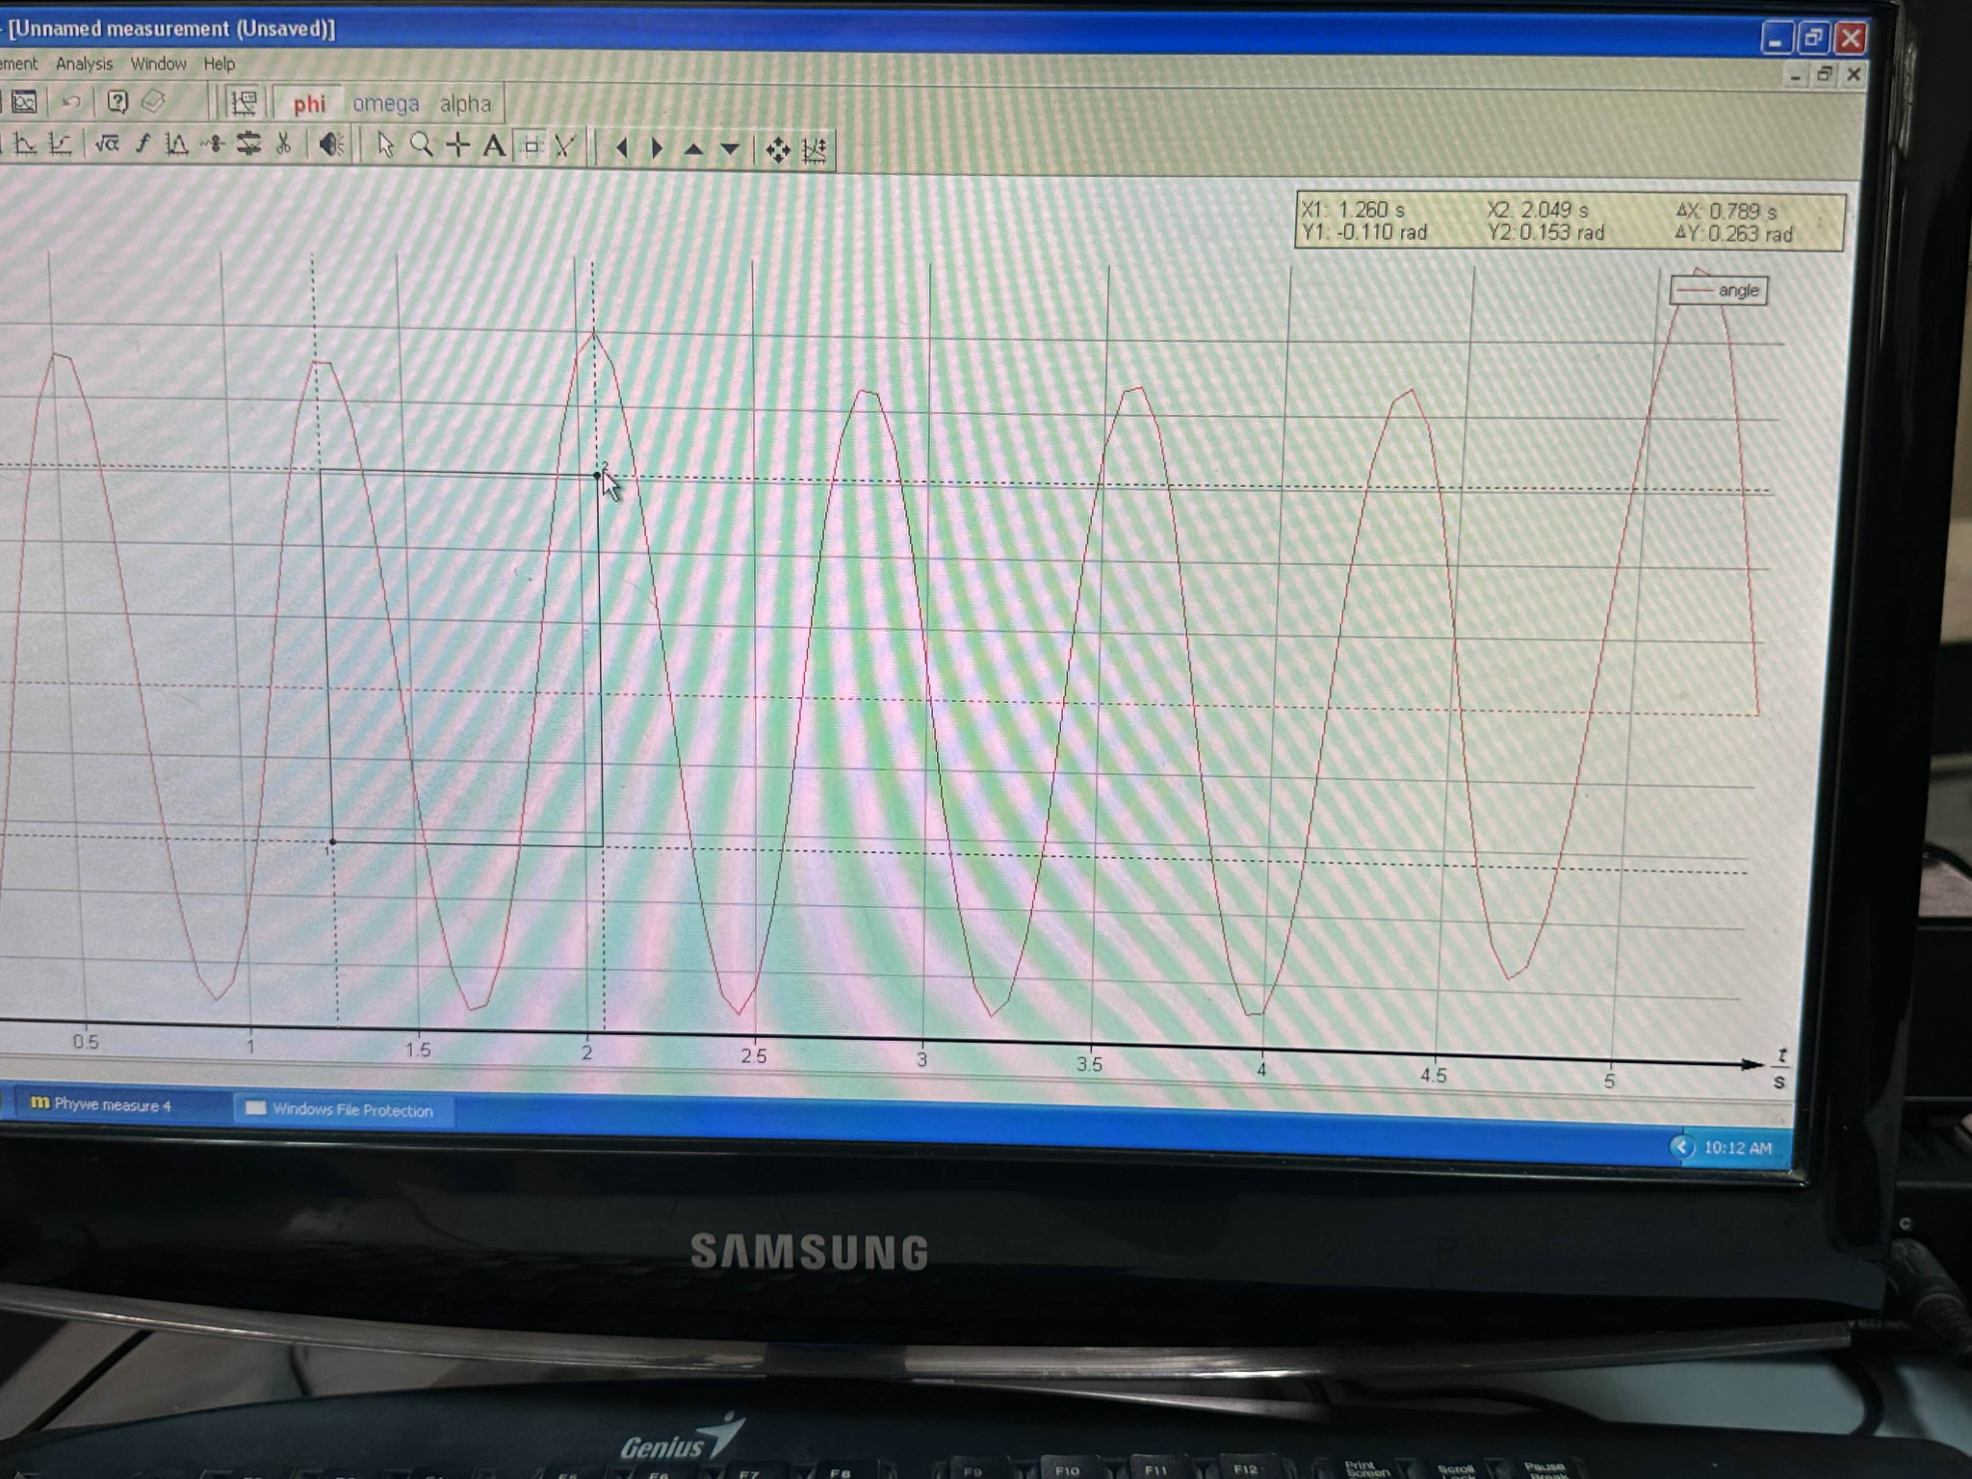

$\underline{g_{1}}=\frac{l}{cos θ_{1} }{\left(\frac{2π}{\underline{T_{1}}}\right)}^{2}=\frac{0.140}{cos(0)}×{\left(\frac{2π}{0.780}\right)}^{2}=9.084 \left(m/s^{2}\right)$

$Δg_{1}=\underline{g_{1}}×\sqrt{{{\left(-2\frac{ΔT_{1}}{\underline{T_{1}}}\right)}^{2}}^{}}$ $=9.084 ×\sqrt{{\left(-2\frac{0.013}{0.780}\right)}^{2}}$ $= 0.303 \left(m/s^{2}\right)$

$⇒g_{1}=9.084±0.303 \left(m/s^{2}\right)$

b) $θ_{2}={15}^{0}$

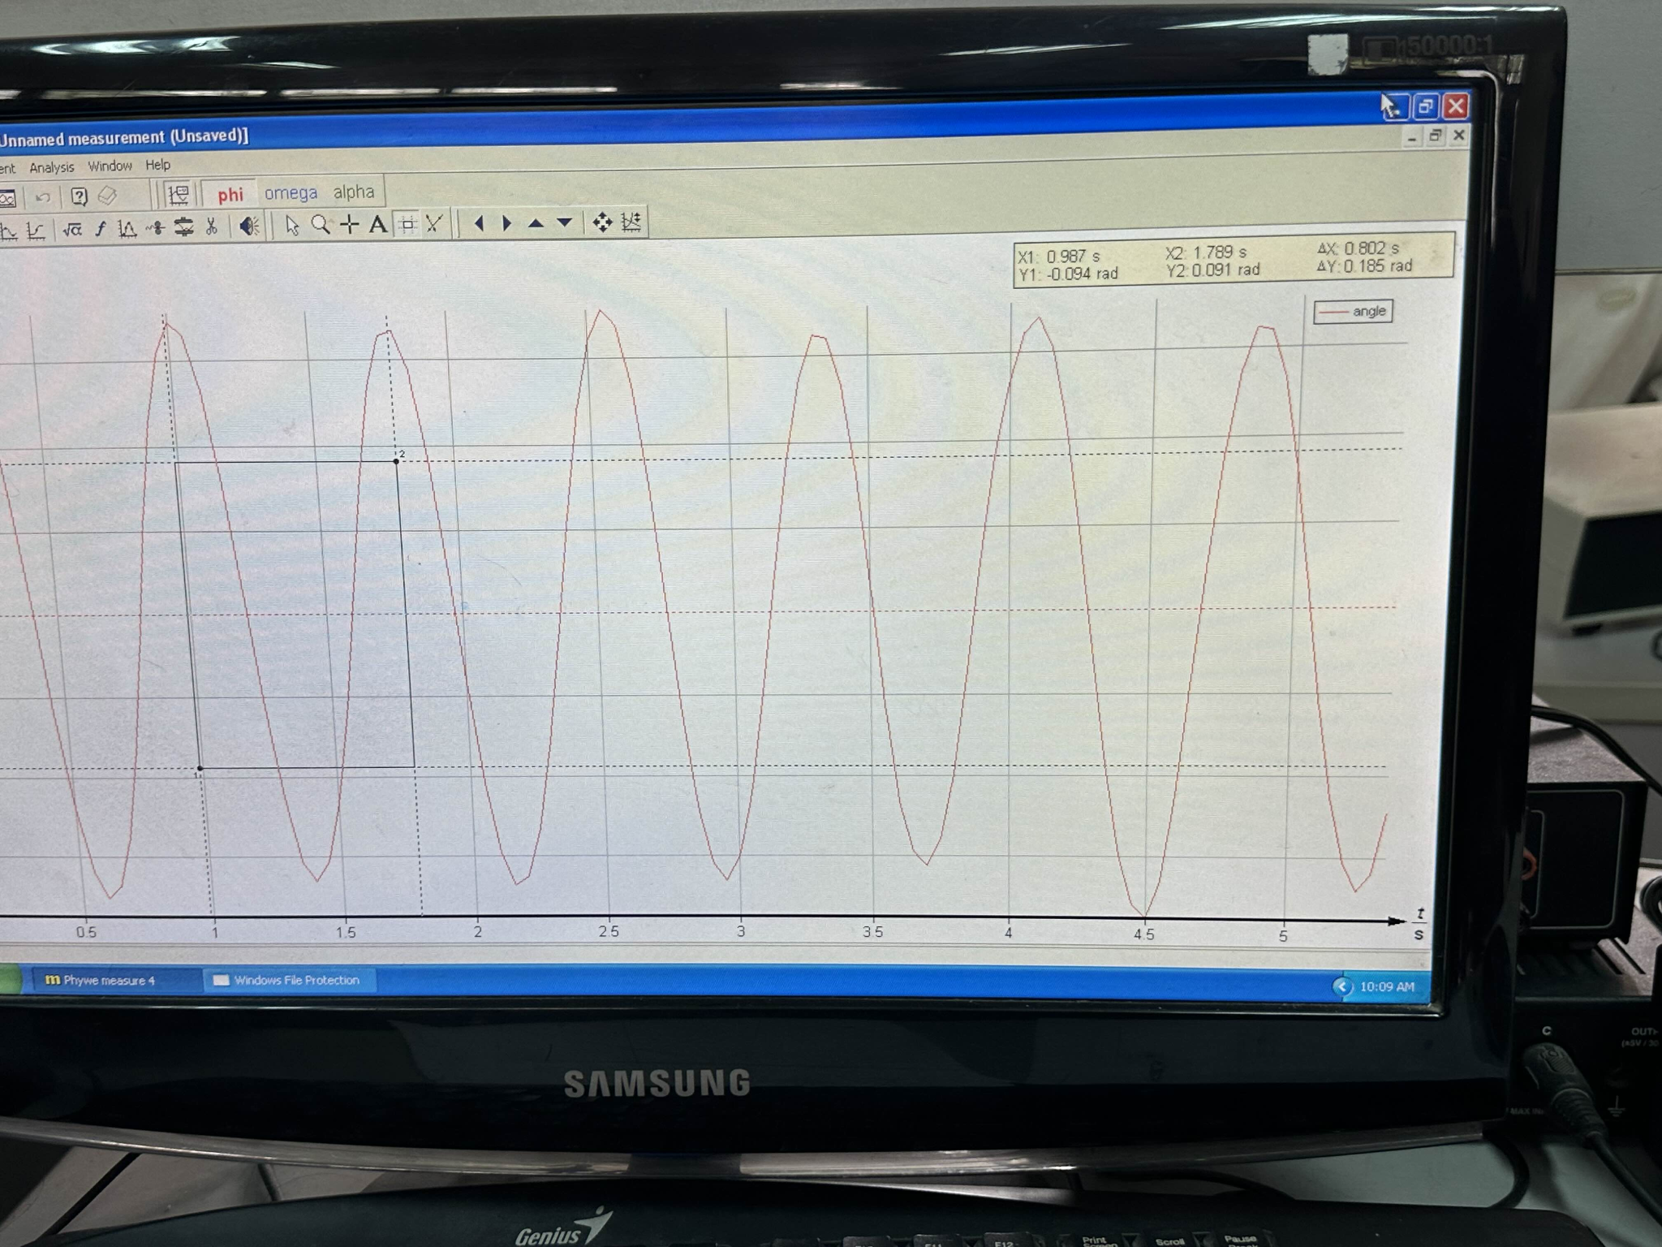

$\underline{g_{2}}=\frac{l}{cos θ_{2} }{\left(\frac{2π}{\underline{T_{2}}}\right)}^{2}=\frac{0.140}{cos(15)}×{\left(\frac{2π}{0.779}\right)}^{2}=9.430 \left(m/s^{2}\right)$

$Δg_{2}=\underline{g_{2}}×\sqrt{{{\left(-2\frac{ΔT_{2}}{\underline{T_{2}}}\right)}^{2}}^{}}$ $=9.430 ×\sqrt{{\left(-2\frac{0.020}{0.779}\right)}^{2}}$ $= 0.484 \left(m/s^{2}\right)$

$⇒g_{2}=9.430±0.484 \left(m/s^{2}\right)$

c) $θ_{3}={35}^{0}$

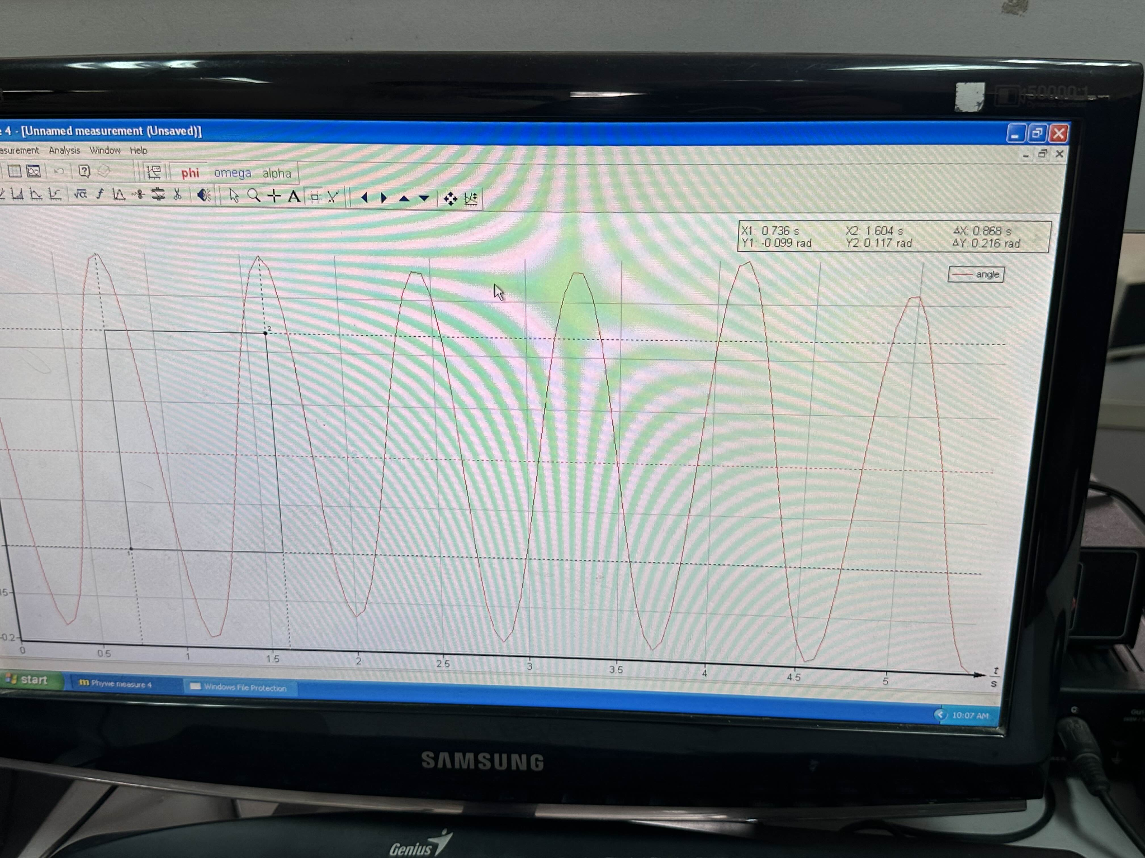

$\underline{g_{3}}=\frac{l}{cos θ_{3} }{\left(\frac{2π}{\underline{T_{3}}}\right)}^{2}=\frac{0.140}{cos(35)}×{\left(\frac{2π}{0.846}\right)}^{2}=9.428 \left(m/s^{2}\right)$

$Δg_{3}=\underline{g_{3}}×\sqrt{{{\left(-2\frac{ΔT_{3}}{\underline{T_{3}}}\right)}^{2}}^{}}$ $=9.428×\sqrt{{\left(-2\frac{0.015}{0.846}\right)}^{2}}$ $= 0.334 \left(m/s^{2}\right)$

$⇒g_{3}=9.428±0.334 \left(m/s^{2}\right)$

d) $θ_{4}={45}^{0}$

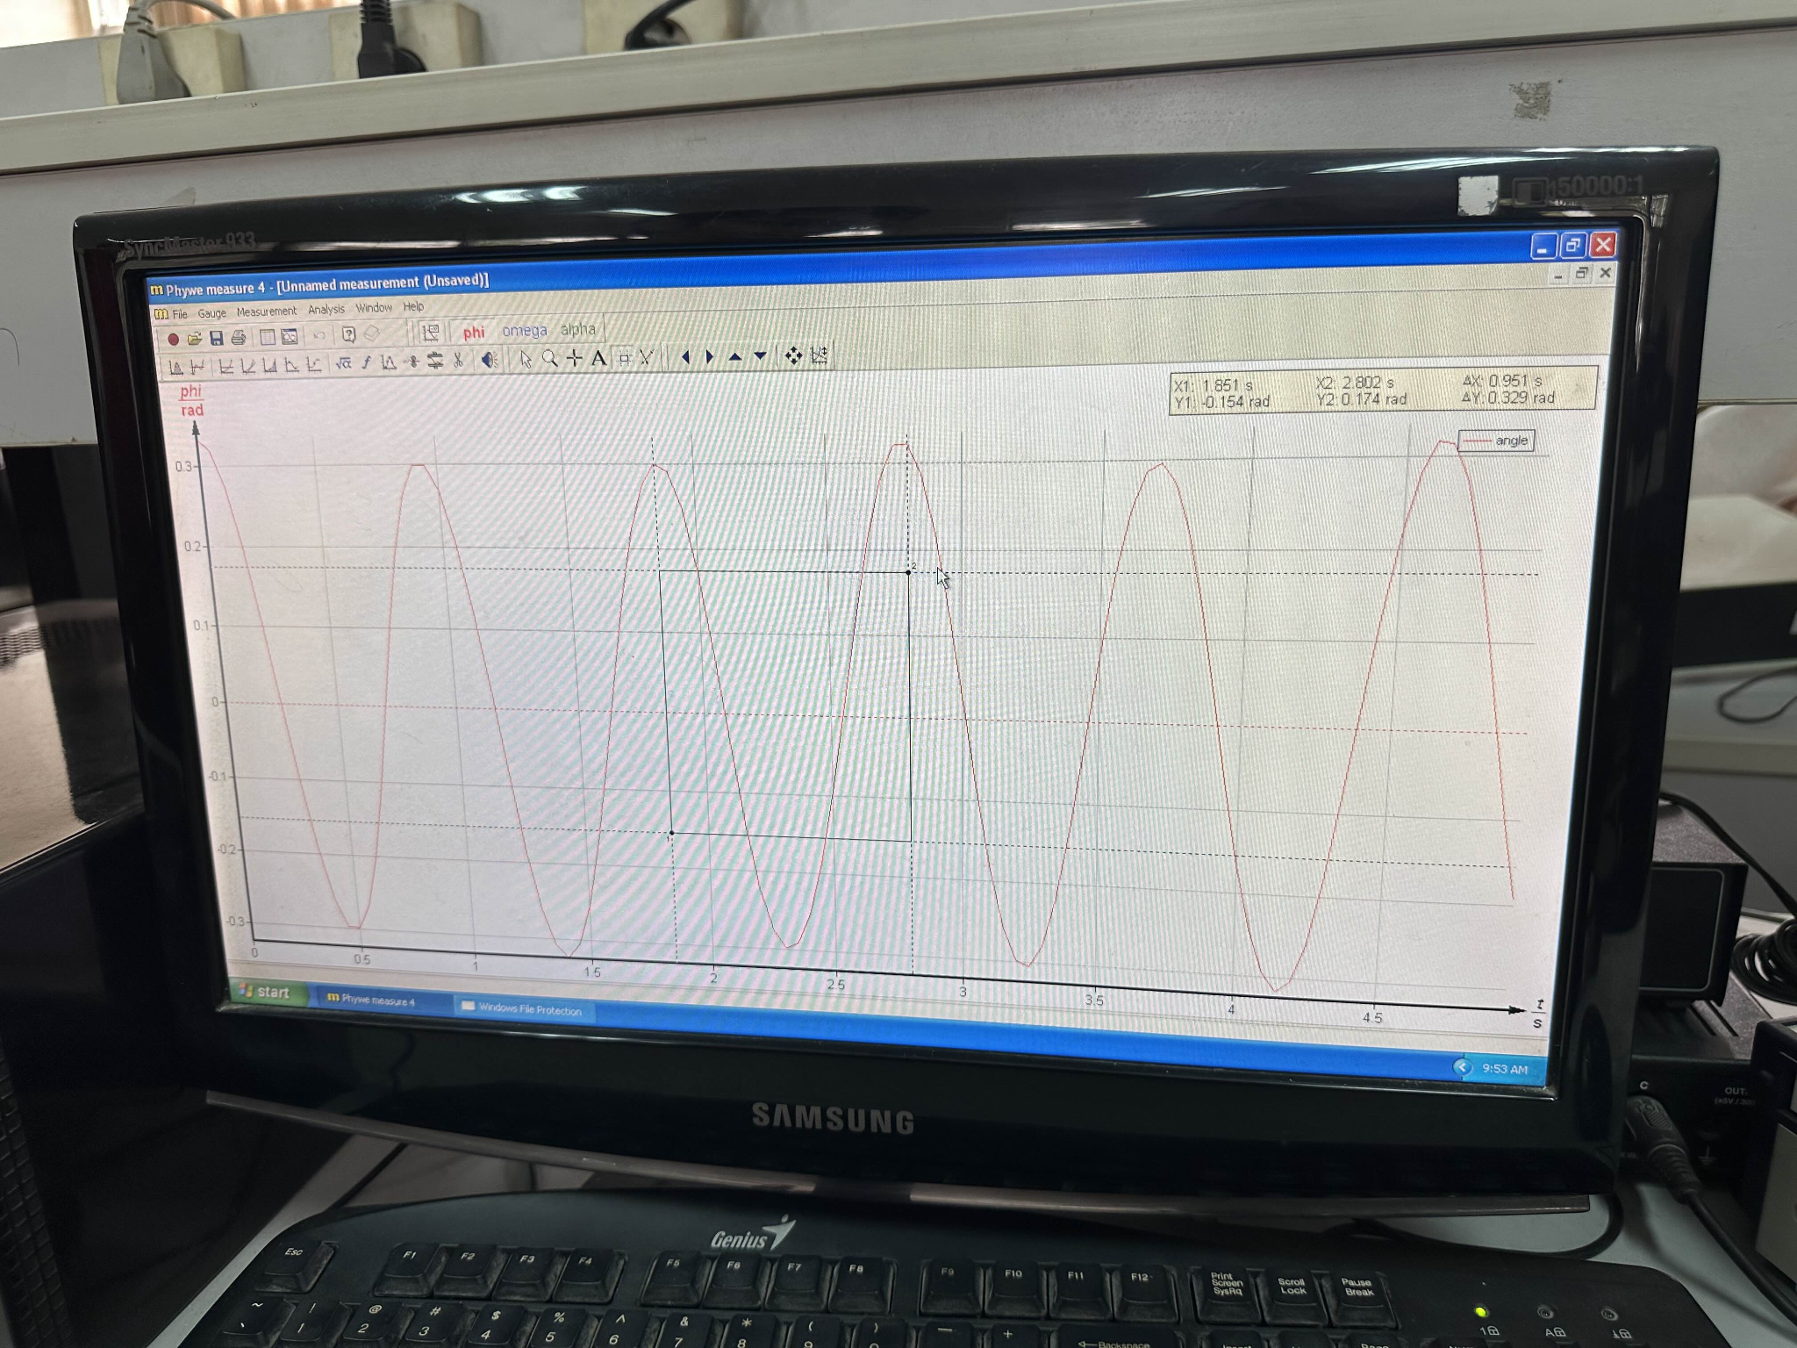

$\underline{g_{4}}=\frac{l}{cos θ_{4} }{\left(\frac{2π}{\underline{T_{4}}}\right)}^{2}=\frac{0.140}{cos(45)} ×{\left(\frac{2π}{0.919}\right)}^{2}=9.254 \left(m/s^{2}\right)$

$Δg_{4}=\underline{g_{4}}×\sqrt{{{\left(-2\frac{ΔT_{4}}{\underline{T_{4}}}\right)}^{2}}^{}}$ $=9.254 ×\sqrt{{\left(-2\frac{0.016}{0.919}\right)}^{2}}$ $= 0.322 \left(m/s^{2}\right)$

$⇒g_{4}=9.254±0.322 \left(m/s^{2}\right)$

e) $θ_{5}={65}^{0}$

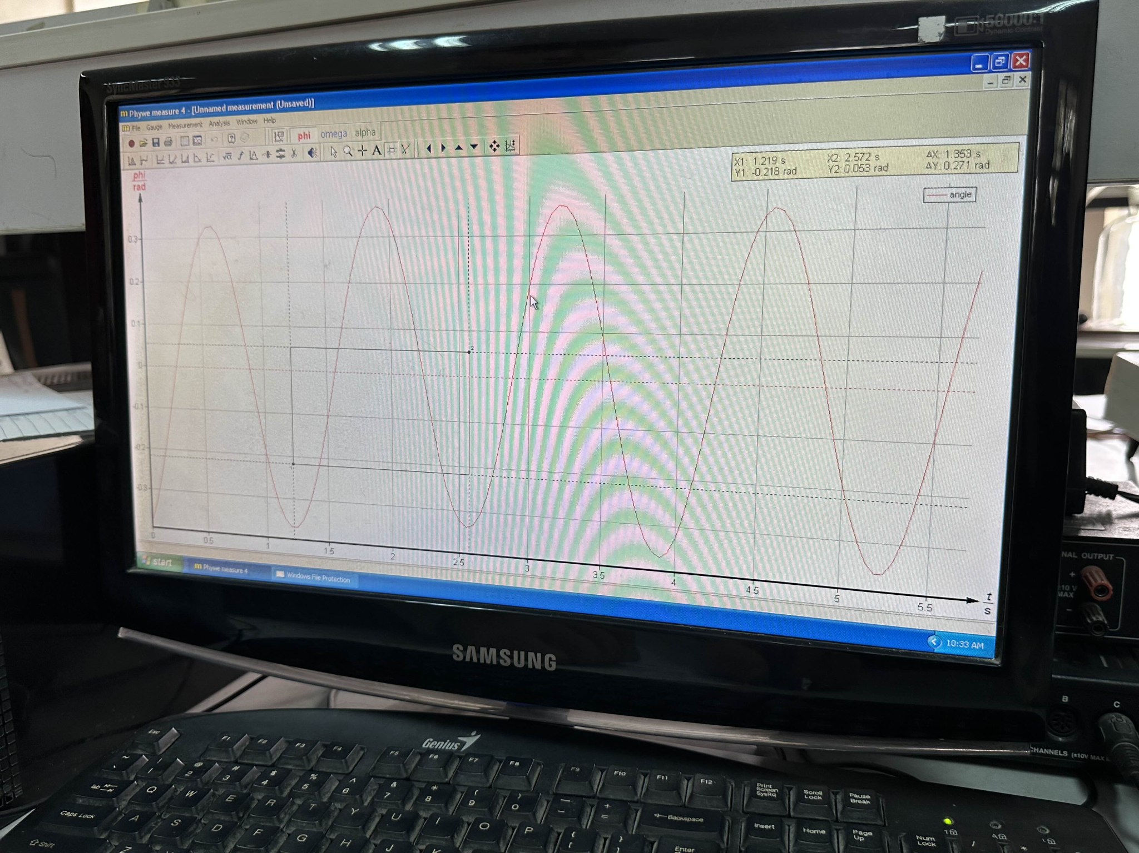

$\underline{g_{5}}=\frac{l}{cos θ_{5} }{\left(\frac{2π}{\underline{T_{5}}}\right)}^{2}=\frac{0.140}{cos(70)}{ ×\left(\frac{2π}{1.332}\right)}^{2}=7.360 \left(m/s^{2}\right)$

$Δg_{5}=\underline{g_{5}}×\sqrt{{{\left(-2\frac{ΔT_{5}}{\underline{T_{5}}}\right)}^{2}}^{}}$ $=7.360\sqrt{{\left(-2\frac{0.021}{1.332}\right)}^{2}}$ $= 0.232 \left(m/s^{2}\right)$

$⇒g_{5}=7.360±0.232 \left(m/s^{2}\right)$

Gravitational acceleration is independent of the length of the rod or the angle of the inclined oscillation plane because it is primarily influenced by factors such as altitude, depth, air density, and the gravitational pull of celestial bodies like the Moon and the Sun. Measurement inaccuracies and environmental conditions, including variations in temperature and pressure, can contribute to experimental errors.